Fine Motor and Functional Skills Milestones

Age | Grasp | Prewriting | Drawing | Handwriting | Coloring | Cutting | Button | Zip | Shoes
3 years | Digital pronate grasp  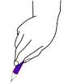 | Copies a circle, vertical & horizontal lines | Initiates drawing a person with assistance | Not present | Attempts to color within lines of large spaces with minimal success | Snips paper, cuts across | Begins buttoning large buttons | Begins zipping and unzipping | Not present
4 years | Static Tripod | Copies cross and square | Begins drawing a person with a head, arms and legs | Begins copying name | Begins to stay within large space boundary lines, 25% of picture | Cuts circles & squares | Buttons medium sized buttons | Connects/interlocks zipper | Not present, may show interest
5 years | 3-finger Tripod  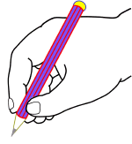 | Copies “X,” triangle and rectangle | Begins drawing a person with ___ body parts | Begins copying letters | Colors close to lined boundaries, 75% of picture | Cuts out pictures and shapes with curved lines/angles, staying on the line <50% | Masters buttoning | Masters zipping | Begins shoe tying

